CYBER SECURITY TASK 3
API Security Risk Analysis
Future Interns Cyber Security Internship 2026
Prepared by
Harsha Vardhan
API Tested: JSONPlaceholder
Tool Used: Postman
Testing Date: 01 October 2026

1. Executive Summary
This report documents a read-only security risk analysis of JSONPlaceholder (https://jsonplaceholder.typicode.com), a free public REST API intended for prototyping and testing. The assessment was performed with Postman using GET requests only, and covered authentication, access control, data exposure, HTTP response headers, rate limiting and input handling.
Overall result: No High or Medium severity vulnerability was confirmed. The observations recorded in this report are Informational or Low and are largely a consequence of JSONPlaceholder being a deliberately open demo service with synthetic data. They are documented because the same patterns would be significant if found in a production API that handles real customer data.
Key observations:
- All tested endpoints (/posts, /users, /users/1, /posts/1/comments) returned 200 OK without any credentials.
- A request for a non-existent resource (/users/9999) returned 404 Not Found with an empty JSON object and no sensitive error detail.
- User records expose name, username, email and address fields, which would be personal data in a real system.
- The captured response headers include Access-Control-Allow-Credentials: true; only a subset of the 22 headers was captured, so related CORS and security headers were not assessed.

2. Objective
The objective of this task is to perform a safe, read-only security review of a public demo API, identify potential risks in how it handles authentication, authorization, data and requests, rate each observation by severity, explain the business impact, and recommend practical remediation. The assessment is also intended to demonstrate a structured, evidence-based approach that does not overstate findings.

3. Scope & Ethics

In scope
- https://jsonplaceholder.typicode.com/posts
- https://jsonplaceholder.typicode.com/users
- https://jsonplaceholder.typicode.com/users/1
- https://jsonplaceholder.typicode.com/posts/1/comments
- https://jsonplaceholder.typicode.com/users/9999 (non-existent resource test)

Out of scope
- Any write operations (POST, PUT, PATCH, DELETE).
- Load, stress or denial-of-service testing.
- Exploitation attempts, injection payloads, fuzzing or brute-force activity.
- Any API, account or system other than JSONPlaceholder.

Ethical approach
JSONPlaceholder is a public service that exists for testing and learning. Testing was limited to a small number of read-only GET requests, no credentials or real personal data were involved, and no attempt was made to disrupt or degrade the service. All data returned by the API is synthetic.

4. Tools Used
Tool | Purpose
Postman | Sending GET requests, inspecting status codes, response bodies, response times and headers, and capturing evidence screenshots.
JSONPlaceholder | Target public REST API (fake online REST API for testing and prototyping).
OWASP API Security Top 10 (2023) | Reference framework for mapping observations.

5. Methodology
The assessment followed a simple, repeatable sequence:
- Defined scope and rules of engagement (read-only, public demo API).
- Created a Postman collection named “Cyber Security Task 3 - API Security Analysis” to organise the work.
- Sent GET requests to the in-scope endpoints and recorded status code, response time and response size.
- Reviewed the response bodies for the type and sensitivity of data returned.
- Tested authentication by sending a request with the Authorization type set to No Auth.
- Tested access-control behaviour by requesting a non-existent user ID.
- Inspected the response headers returned by the server.
- Mapped observations to the OWASP API Security Top 10 (2023) and rated severity.

6. API Endpoints Tested
Endpoint | Method | Status | Time | Size | Evidence
/posts | GET | 200 OK | 148 ms | 7.76 KB | Figure 1
/users | GET | 200 OK | 406 ms | 2.67 KB | Figure 2
/users/1 | GET | 200 OK | 142 ms | 1.21 KB | Figure 3
/posts/1/comments | GET | 200 OK | 141 ms | 1.52 KB | Figure 4
/users/1 (No Auth) | GET | 200 OK | 60 ms | 1.21 KB | Figure 6
/users/9999 | GET | 404 Not Found | 642 ms | 909 B | Figure 7

7. Authentication Assessment
Item | Result
Endpoint | GET /users/1
Authorization type | No Auth
Response | 200 OK
Observation | The user record was returned with no credentials, token or API key supplied.
Severity | Informational

The endpoint is fully accessible without authentication. For JSONPlaceholder this is expected behaviour, as the service is a public sandbox with fake data and has no concept of accounts or sessions. It is therefore not rated as a vulnerability. If the same behaviour were found on a production API serving real user records, it would be a serious weakness (OWASP API2:2023 Broken Authentication), because anyone could read user data anonymously.
Evidence: Figure 6.

8. Access-Control Assessment
Item | Result
Endpoint | GET /users/9999
Response | 404 Not Found
Response body | Empty JSON object ({})
Observation | A non-existent object is handled cleanly, with no stack trace, internal path or data leakage.
Severity | Informational (no issue identified)

Limitation: Full BOLA (Broken Object Level Authorization) testing was not possible because JSONPlaceholder has no authenticated or private users. There are no user accounts, sessions or tokens, and therefore no ownership boundary between one user’s objects and another’s that could be tested. The /users/9999 request only confirms that a non-existent identifier is rejected gracefully; it does not demonstrate that object-level authorization is enforced.
Evidence: Figure 7.

9. Data Exposure Assessment
Response bodies were reviewed for the sensitivity of the fields returned.
Endpoint | Fields observed | Comment
/users, /users/1 | id, name, username, email, address (street, suite, city, zipcode, geo lat/lng) | Personal-data-like fields. Synthetic in JSONPlaceholder, but would be personal data in a real system.
/posts | userId, id, title, body | Public-style content; no sensitive fields observed.
/posts/1/comments | postId, id, name, email, body | Commenter email addresses are exposed to any caller.

Because the data is fictional, no real privacy impact exists. The observation is rated Low (context-dependent): a production API should return only the fields each caller is authorised to see (OWASP API3:2023 Broken Object Property Level Authorization). Evidence: Figures 1–4.

10. HTTP Header Assessment
The response headers were inspected in Postman. The captured view shows nine of the 22 header entries returned; the remainder were not captured.
Header | Value observed | Comment
Content-Type | application/json; charset=utf-8 | Correct, explicit content type and charset.
Access-Control-Allow-Credentials | true | Permits credentialed cross-origin requests. Risk depends on the Access-Control-Allow-Origin value, which was not captured. Should be verified.
Cache-Control | max-age=43200 | Responses cacheable for 12 hours.
Expires / Pragma | -1 / no-cache | Conflicts in intent with the max-age directive; Cache-Control takes precedence in modern clients. Informational.
Content-Encoding | gzip | Compression enabled.
Etag | Weak ETag present | Supports conditional requests.
Vary | Origin, Accept-Encoding | Appropriate for CORS and compression.

Security-related headers such as Strict-Transport-Security, X-Content-Type-Options and Content-Security-Policy were not visible in the captured portion. Their absence is therefore not asserted; a complete header review would be needed to confirm. Evidence: Figure 5.

11. Rate Limiting
Rate limiting was not actively tested. Doing so requires sending high-volume traffic, which is outside the read-only, non-disruptive scope of this assessment. The captured headers did not include rate-limit indicators (for example X-RateLimit-* or Retry-After), and no 429 Too Many Requests response was encountered during the individual requests.
This is recorded as Informational. For a production API, absent or weak rate limiting can enable scraping, enumeration and resource exhaustion (OWASP API4:2023 Unrestricted Resource Consumption).

12. Input Validation
Input validation testing was intentionally minimal. The only non-standard input was a non-existent identifier (9999) on /users/{id}, which returned 404 Not Found with an empty JSON object. This indicates predictable error handling for an unknown resource.
No injection strings, malformed payloads, oversized inputs or write requests were sent, so conclusions about input validation beyond this simple case cannot be drawn.

13. Risk Summary
No High or Medium severity vulnerability was confirmed. Observations are listed below with their severity in the context of this public demo API.
ID | Observation | Severity | OWASP 2023 | Status
R-01 | Endpoints accessible without authentication | Informational | API2 | Expected for public demo API
R-02 | Personal-data-like fields returned (name, email, address) | Low | API3 | Synthetic data; design note
R-03 | Access-Control-Allow-Credentials: true observed | Low | API8 | Needs full CORS review
R-04 | No rate-limit indicators observed; not actively tested | Informational | API4 | Not tested
R-05 | Mixed caching directives (max-age with Expires -1 / no-cache) | Informational | API8 | Hygiene note

Severity reflects the real-world context of the target. These ratings would be re-evaluated, and R-01 and R-02 would likely increase, if the same behaviour were found in an API handling real customer data.

14. Business Impact
For JSONPlaceholder itself, business impact is negligible: the service is a public sandbox with fictional data. The analysis is still useful as a model of what these patterns would mean for an organisation running a similar API in production:
- Data privacy: unauthenticated access to records containing names, emails and addresses could lead to a personal-data breach.
- Regulatory exposure: exposure of personal data may trigger obligations under laws such as India’s Digital Personal Data Protection Act, 2023 or GDPR.
- Reputation and trust: customers lose confidence quickly after a data exposure incident.
- Abuse and availability: missing rate limits allow scraping and automated abuse, increasing cost and reducing service reliability.

15. Remediation Recommendations
The recommendations below apply to production APIs that show the patterns observed in this assessment.
Ref | Recommendation | Addresses | Priority
1 | Require authentication (for example OAuth 2.0 / OpenID Connect or short-lived signed tokens) on every endpoint that returns non-public data. | R-01 | High (prod)
2 | Enforce object-level and property-level authorization on the server for every request; never rely on obscure identifiers. | R-01, R-02 | High (prod)
3 | Return only the fields needed by each client using response schemas / DTOs; avoid exposing email and address data by default. | R-02 | Medium
4 | Restrict CORS to an explicit origin allow-list and enable Access-Control-Allow-Credentials only where required. | R-03 | Medium
5 | Apply rate limiting and throttling per client, return 429 with Retry-After, and monitor for abnormal request volumes. | R-04 | Medium
6 | Add standard security headers (Strict-Transport-Security, X-Content-Type-Options, and others suited to the API) and make caching directives consistent. | R-05 | Low
7 | Keep generic, consistent error responses and validate all inputs against a schema. | Section 12 | Low
8 | Enable logging and alerting for authentication failures and unusual access patterns. | General | Low

16. OWASP API Security Mapping
OWASP API Security Top 10 (2023) | Relevance to this assessment | Result
API1: Broken Object Level Authorization | Could not be fully tested; no authenticated or private users exist. | Not testable
API2: Broken Authentication | Endpoints open by design; no authentication mechanism to assess. | Informational
API3: Broken Object Property Level Authorization | Personal-data-like fields returned to anonymous callers. | Low
API4: Unrestricted Resource Consumption | No rate-limit indicators seen; not actively tested. | Informational / not tested
API5: Broken Function Level Authorization | Only read (GET) operations tested. | Not tested
API8: Security Misconfiguration | Access-Control-Allow-Credentials observed; mixed caching headers. | Low / Informational
API9: Improper Inventory Management | Only a small, defined set of endpoints reviewed. | Not assessed

17. Limitations
- JSONPlaceholder is a public demo API with fake data, no real users and no authentication layer, so many controls could not be meaningfully tested.
- Full BOLA testing was not possible because there are no authenticated or private users.
- Testing was read-only and limited to a handful of GET requests; write methods were not tested.
- Only a subset of the 22 response headers was captured, so security headers were not fully assessed.
- Rate limiting, injection and fuzzing tests were not performed, in line with the ethical scope.
- Results reflect a single test session on 01 October 2026 and may change over time.

18. Conclusion
The assessment of JSONPlaceholder found it to behave as expected for a public sandbox API: open access, synthetic data and graceful handling of a non-existent resource. No High or Medium severity vulnerability was confirmed, and no findings have been inflated to increase the count. The Low and Informational observations (anonymous access, personal-data-like fields, a credentialed-CORS header and mixed caching directives) are most useful as lessons for production APIs, where they should be addressed through strong authentication, object-level authorization, minimal data exposure, strict CORS, rate limiting and consistent security headers.

19. Evidence / Screenshots
Figure 1: GET /posts – 200 OK
File: figure-1-posts.png
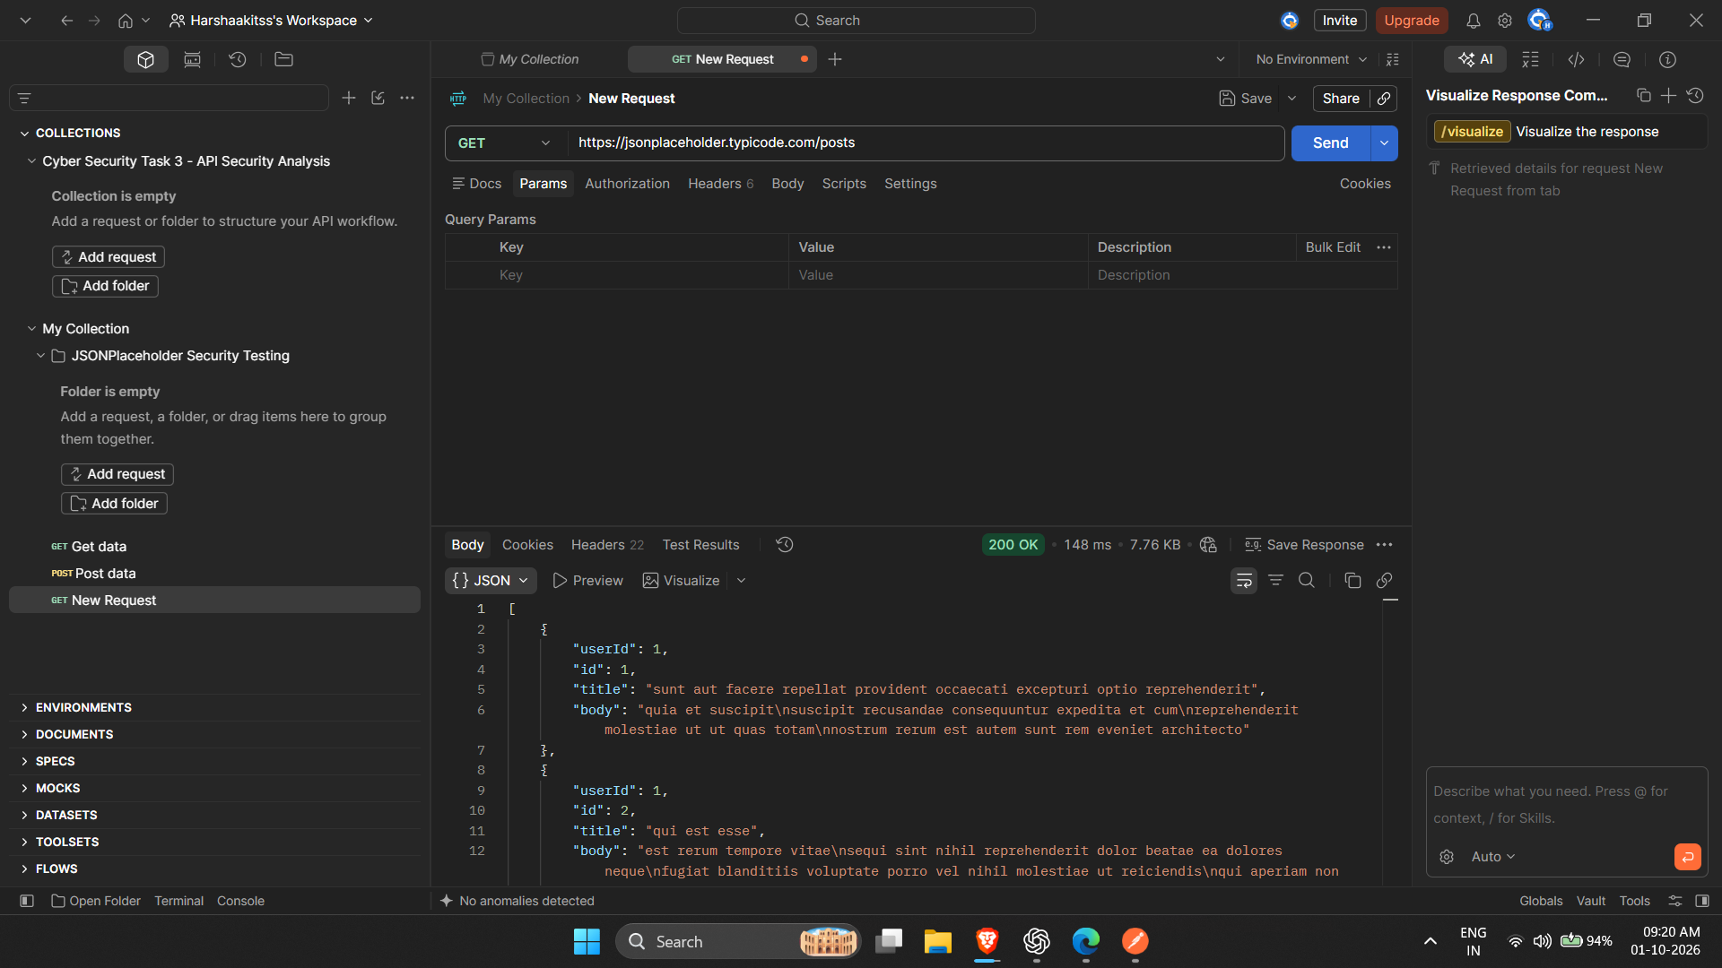
Figure 2: GET /users – 200 OK
File: figure-2-users.png
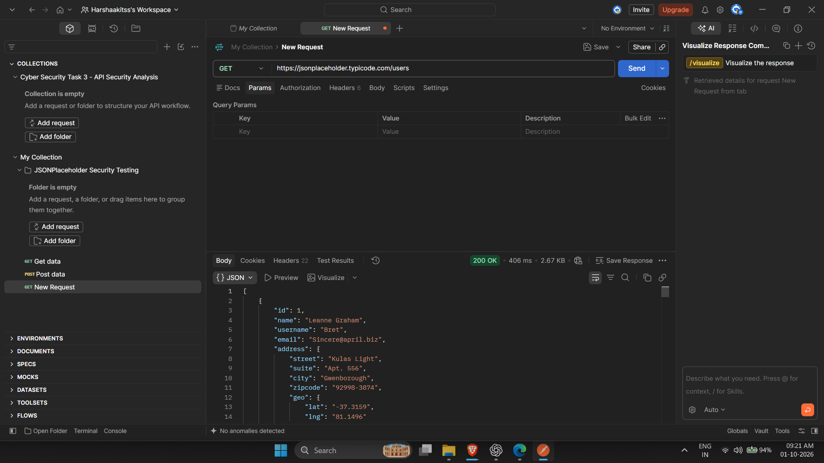
Figure 3: GET /users/1 – 200 OK
File: figure-3-users-1.png
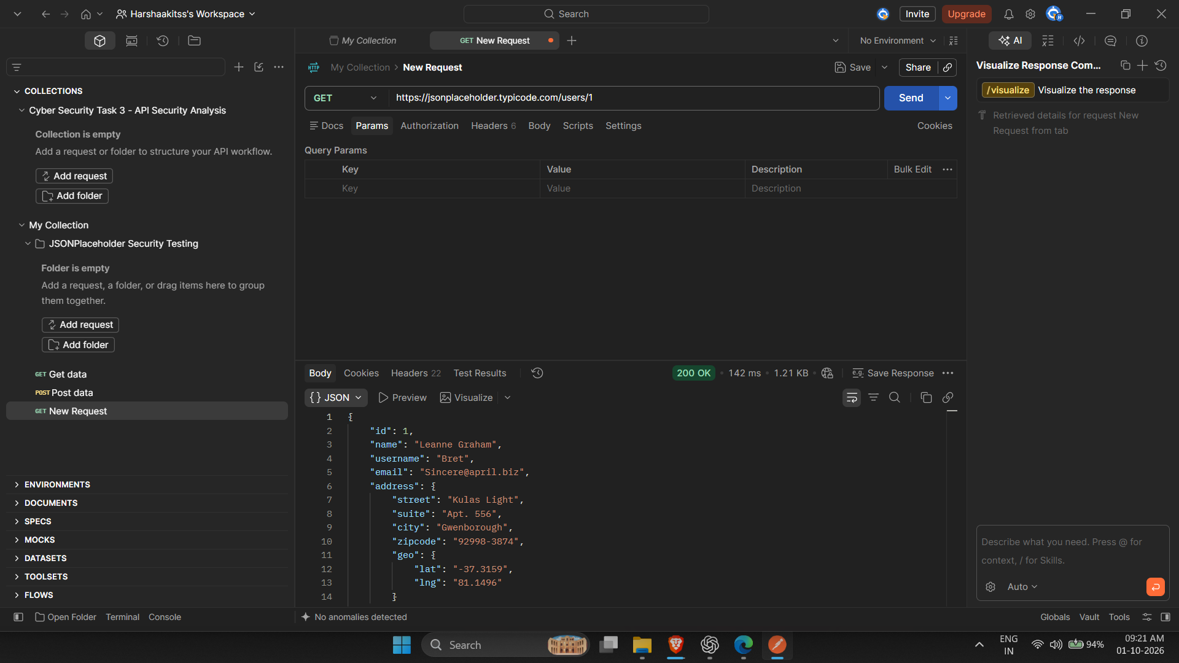
Figure 4: GET /posts/1/comments – 200 OK
File: figure-4-posts-1-comments.png
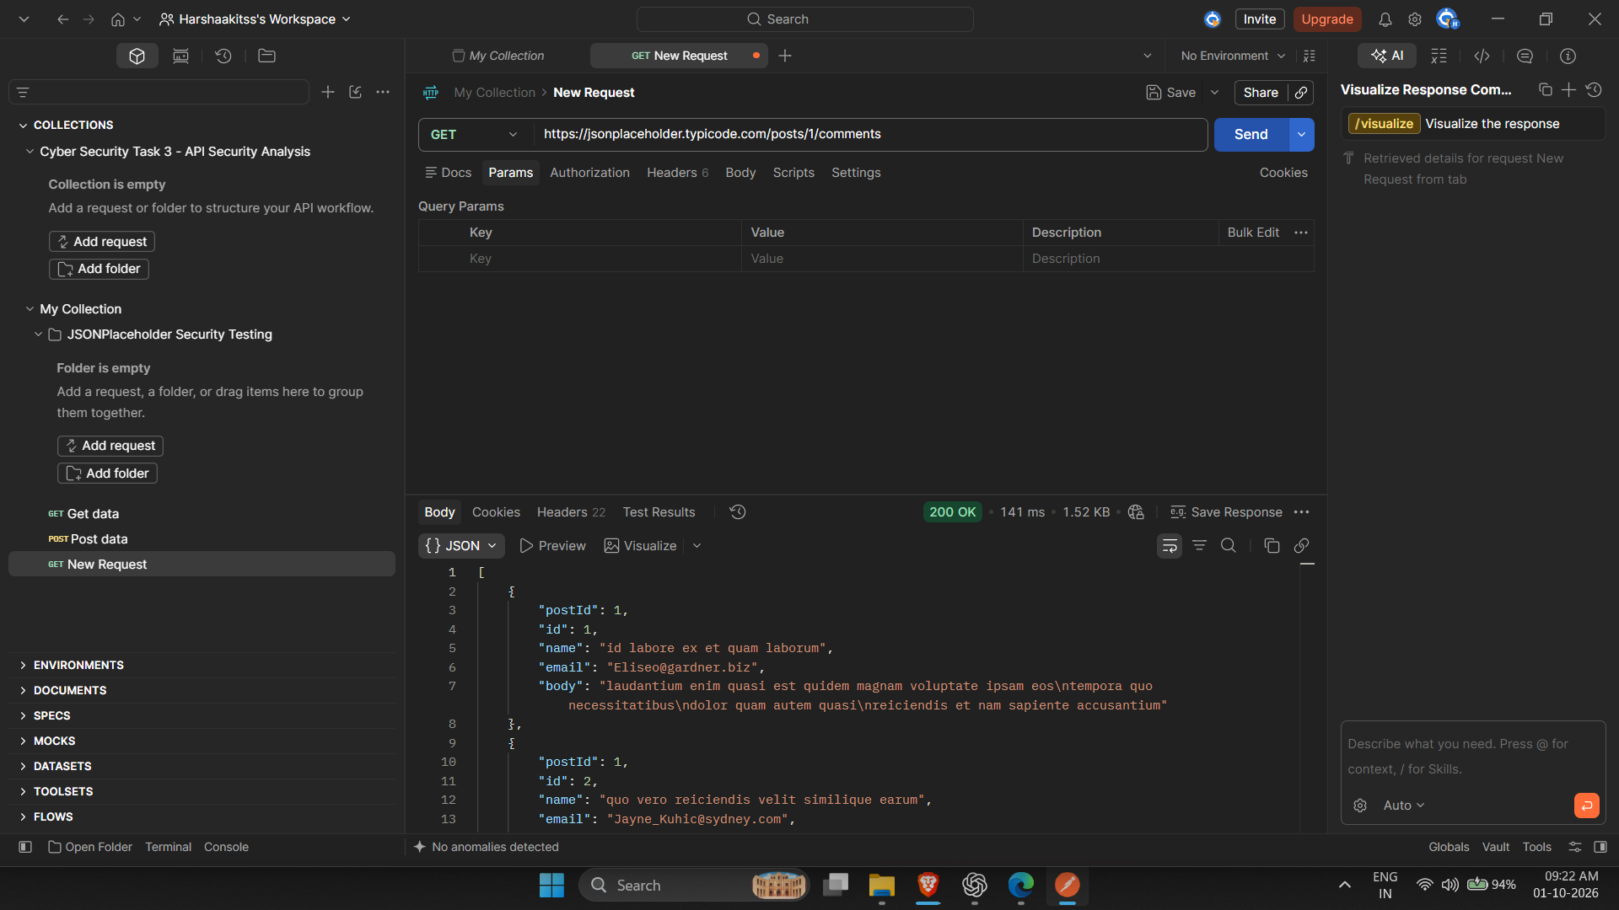
Figure 5: Response headers
File: figure-5-response-headers.png
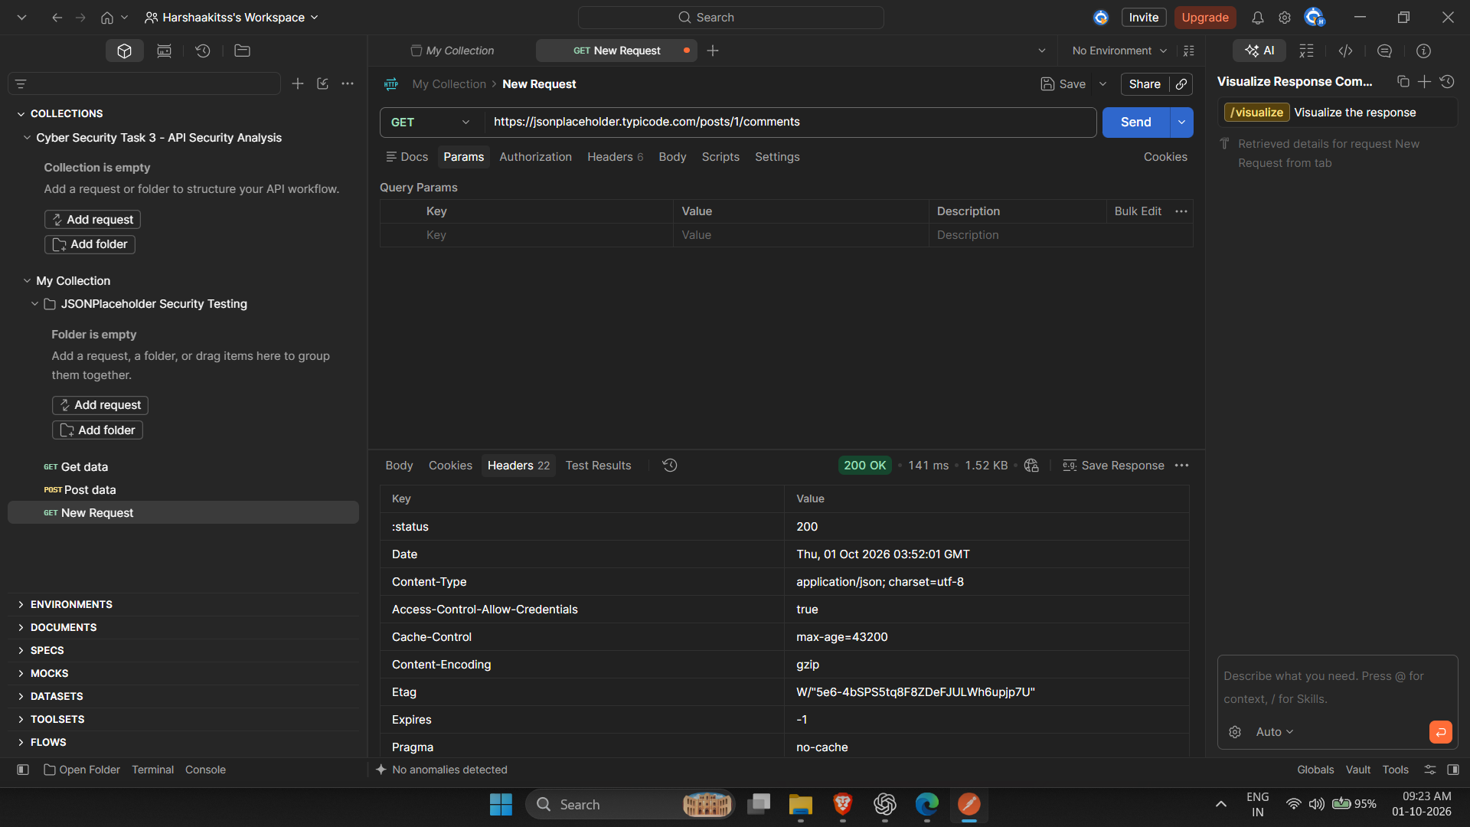
Figure 6: Authentication – No Auth
File: figure-6-authentication-no-auth.png
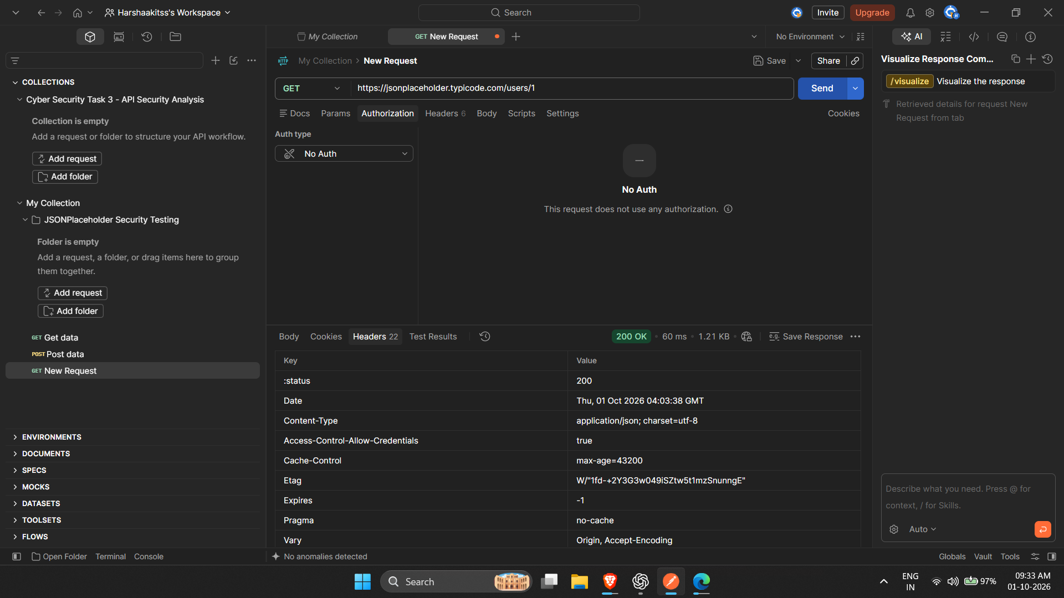
Figure 7: Access-control – /users/9999 → 404 Not Found
File: figure-7-access-control-users-9999-404.png
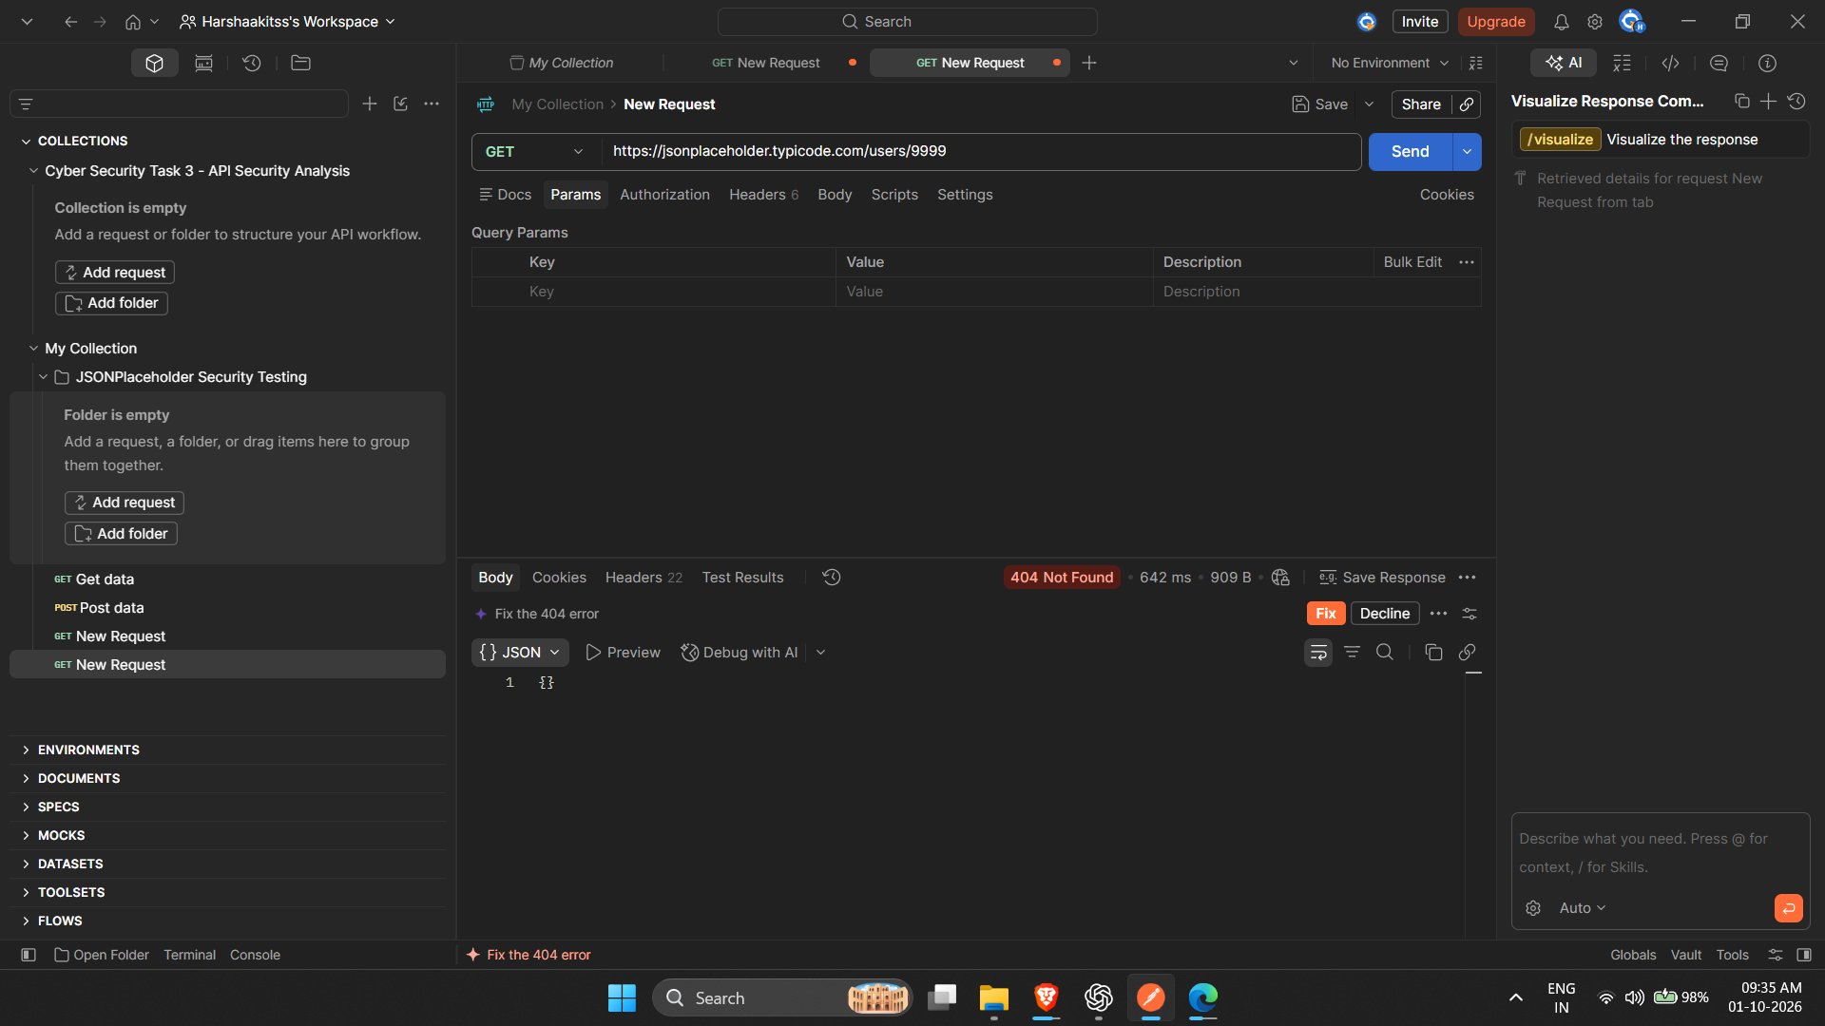

20. References
- JSONPlaceholder – Free fake and reliable API for testing and prototyping: https://jsonplaceholder.typicode.com
- Postman – API platform: https://www.postman.com
- OWASP API Security Top 10 – 2023 edition: https://owasp.org/API-Security/editions/2023/en/0x11-t10/
- OWASP REST Security Cheat Sheet: https://cheatsheetseries.owasp.org/cheatsheets/REST_Security_Cheat_Sheet.html
- Future Interns – Cyber Security Internship Task 3 brief

